**Survey Programmer**

### **A Project Report Submitted**

**in Partial Fulfillment of the**

**Requirements**

**for the Degree of**

**MASTER OF COMPUTER APPLICATION**

### **by**

**Ujjawal Kuchhal - 1802914017**

**Under the Supervision of**

**Dr. Sangeeta Arora**

**KIET Group of Institution, Ghaziabad**



**to the**

**FACULTY OF COMPUTER APPLICATIONS**

**DR. APJ ABDUL KALAM TECHNICAL**

**UNIVERSITY LUCKNOW**

**(Formerly Uttar Pradesh Technical University, Lucknow)**

**July,2021**

**Training Certificate**

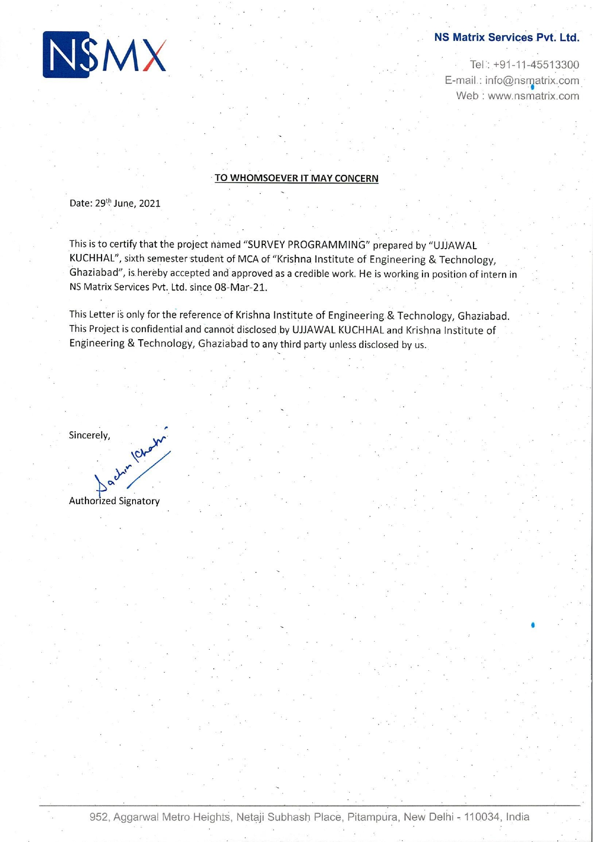

**CERTIFICATE**

Certified that **Ujjawal Kuchhal (University Roll No - 1802914017)** have carried out the project work name “**Survey Programmer**” for Master of Computer Applications from Dr. A.P.J. Abdul Kalam Technical University (AKTU)(formerly UPTU), Technical University, Lucknow under my supervision. The project report embodies original work, and studies are carried out by the student himself/herself and the contents of the project report do not form the basis for the award of any other degree to the candidate or to anybody else from this or any other University/Institution.

**Dr. Sangeeta Arora Signature of External Examiner**

**Associate Professor**

**Department of Computer Applications**

**KIET Group of Institutions, Ghaziabad**

**Dr. Ajay Srivastava**

**Head, Department of Computer Applications**

**KIET Group of Institutions, Ghaziabad**

**Ujjawal Kuchhal**

**Survey Programmer**

**ABSTRACT**

Each and every client needs to know about consumer behavior as you are. So, to find the best ways to get to the data that will deliver the most meaningful insights for businesses, PM programming specializes in cross platform survey programming, data reporting and visualization. Utilizing its robust market research survey and reporting platform, PM programming integrates state-of-the-art technology with traditional research techniques. Programming with PM is all about uncovering opportunities in whatever territory is explored with clients. PM programming isn’t interested in just data, but also about what that data represents for each client. The programming focuses on technology and research systems that bring data to life, and in doing so, helps reveal how even seemingly small discoveries can yield meaningful insights.

**ACKNOWLEDGEMENT**

I take this occasion to thank God, almighty for blessing us with his grace and taking out to a successful culmination. I extend my sincere and heartfelt thanks to our esteemed guide, **Dr. Sangeeta Arora** for providing me with the right guidance and advice at the crucial junctures and for showing me the right way. I extend my sincere thanks to our respected **Head of the department Dr. AJAY SHRIVASTAVA**, for allowing us to use the facilities available. I would like to thank the other faculty members also, at this occasion. Last but not the least, I would like to thank my friends and family for the support and encouragement they have given me during our work.

I would like to express my special thanks of gratitude to my trainer **Mr. Mohit Aaron** as well as for her guidance, help and encouragement throughout my research work. Their enlightening ideas, comments, and suggestions.

**Ujjawal Kuchhal**

**Roll No. - 1802914017**

**TABLE OF CONTENTS**

|  |  |  |
| --- | --- | --- |
| **S.No.** | **TITLES** | **Page No** |
|  | Title Page | i |
|  | Training Certificate (Company) | ii |
|  | Certificate (College) | iii |
|  | Abstract | iv |
|  | Acknowledgment | v |
|  | Table of Contents | vi |
|  | List of Figures | viii |
|  |  |  |
| **1.** | **INTRODUCTION** | **1** |
|  | * 1. Market Research Introduction   2. Security and its Significant   3. Implementation of Market Research   4. Technical Background   1.4.1 Classical Market Techniques  1.4.2 The Market Standard (Des)  1.4.3 The Advanced Market Standard (As) | 1  1  2  3  3  4  4 |
|  |  |  |
| **2.** | **Survey Programmer** |  |
|  | 2.1 Description  2.2 Responsibilities 2.3 [Benefits of survey programming](javascript:void(0))2.4 [How can market researchers use survey programming?](javascript:void(0)) | 5  5  6  7 |
|  |  |  |
|  |  |  |
| **3.** | **BUSINESS RESEARCH** |  |
|  | 3.1 Problem Description  3.2 Specification of Market Techniques  3.2.1.1 Market Research  3.2.1.2 Hill Cipher  3.2.1.3 Research and Market Sectors  3.2.1.4 Influence from the Internet  3.2.1.5 Research and Social Media Applications  3.2.1.5.1 International Plan  3.3 Testing and Comparative Analysis | 9  10  11  12  12  13  13  14  14 |
|  |  |  |
| **4.** | **TOOLS** |  |
|  | 4.1 Packages  4.2 Methods  4.3 Premium Pricing  4.4 Creating survey in PM Tool (My work)  4.4.1 Overview of the Portal  4.4.2 Creating a New Project  4.4.3 Basic Question Types  4.4.4 Adding & managing images  4.4.5 Style Editor  4.4.6 Data Verification  4.4.7 Adding Logic  4.4.8 Elements  4.4.9 Sample Sources  4.4.10 Theme Editor  4.4.11 Upload System Files  4.5 Data Validation and preparation  4.5.1 PM tool – What is it?  4.5.2 PM tool -Quick Overview Main Features  4.5.3 PM Tool Data View  4.5.4 PM Tool Variable View  4.5.5 Data Analysis  4.5.6 PM Tool Output Window  4.5.7 PM Tool Reporting | 16  17  17  19  19  21  22  30  32  32  34  40  42  42  42  43  43  43  43  44  45  46  47 |
|  |  |  |
| **5.** | **Literature Review** | 48 |
|  |  |  |
| **6.** | **APPENDICES** | 55 |
|  | **REFERENCES** | 56 |
|  |  |  |

List Of Figures

Figure Name Title Page No.

1. Fig 4.1 Over View of Portal 18
2. Fig 4.2 Single Select 21
3. Fig 4.3 Single Select Grid 22
4. Fig 4.4 Multi Select 23
5. Fig 4.5 Multi Select Grid 23
6. Fig 4.6 Drop down 24
7. Fig 4.7 Number 24
8. Fig 4.8 Text 25
9. Fig 4.9 Essay 26
10. Fig 4.10 Descriptive 26
11. Fig 4.11 Button Select 27
12. Fig 4.12 Rating 28
13. Fig 4.13 Slider 28
14. Fig 4.14 Star Rating 29
15. Fig 4.15 Adding & Managing 31
16. Fig 4.16 Editor 32
17. Fig 4.17 Data Verifier 33
18. Fig 4.18 Example 34
19. Fig 4.19 DIMENSIONAL QUESTIONS 35
20. Fig 4.20 DIMENSIONAL QUESTIONS Ex1. 36
21. Fig 4.21 DIMENSIONAL QUESTIONS Ex2. 37
22. Fig 4.22 DIMENSIONAL QUESTIONS Ex3. 37
23. Fig 4.23 DIMENSIONAL QUESTIONS Ex4. 38
24. Fig 4.24 DIMENSIONAL QUESTIONS Ex5. 39
25. Fig 4.25 DIMENSIONAL QUESTIONS Ex6. 39
26. Fig 4.26 DIMENSIONAL QUESTIONS Ex7. 40
27. Fig 4.27 DIMENSIONAL QUESTIONS Ex8. 44
28. Fig 4.28 Variable View 44
29. Fig 4.29 Data Analysis 1 45
30. Fig 4.30 Data Analysis 2 46
31. Fig 4.31 Output Window 46
32. Fig 4.32 Reporting 47

**CHAPTER 1**

**INTRODUCTION**

**MARKET RESEARCH**

In this chapter we will give an introduction about security locks and protection on computer system. Here we also give an overview of how the data and file are encrypted and decrypted in system.

* 1. MARKET RESEARCH INTRODUCTION

**Marketing research** is "the process or set of processes that links the consumers, customers, and end users to the marketer through information — information used to identify and define marketing opportunities and problems; generate, refine, and evaluate marketing actions; monitor marketing performance; and improve understanding of marketing as a process. Marketing research specifies the information required to address these issues, designs the method for collecting information, manages and implements the data collection process, analyzes the results, and communicates the findings and their implications.

It is the systematic gathering, recording, and analysis of qualitative and quantitative data about issues relating to marketing products and services. The goal of marketing research is to identify and assess how changing elements of the marketing mix impacts customer behavior.

* 1. SECURITY AND ITS SIGNIFICANCE

**Market research** is any organized effort to gather information about target markets or customers. It is a very important component of business strategy. The term is commonly interchanged with **marketing research** however, expert practitioners may wish to draw a distinction, in that *marketing* research is concerned specifically about marketing processes, while *market* research is concerned specifically with markets.

Market research is a key factor in maintaining competitiveness over competitors. Market research provides important information to identify and analyze the market need, market size and competition.

Market research, which includes social and opinion research, is the systematic gathering and interpretation of information about individuals or organizations using statistical and analytical methods and techniques of the applied social sciences to gain insight or support decision making.

Market segmentation is the division of the market or population into subgroups with similar motivations. It is widely used for segmenting on geographic differences, personality differences, demographic differences, technographic differences, use of product differences.

* 1. **IMPLEMENTATION OF MARKET RESEARCH**

**SWOT ANALYSIS**

SWOT is a written analysis of the **Strengths, Weaknesses, Opportunities and Threats** to a business entity. Not only should a SWOT be used in the creation stage of the company but could also be used throughout the life of the company. A SWOT may also be written up for the competition to understand how to develop the marketing and product mixes.

Another factor that can be measured is marketing effectiveness. This includes

* Customer analysis
* Choice modeling
* Competitor analysis
* Risk analysis
* Product research
* Advertising the research
* Marketing mix modeling
* Simulated Test Marketing\

**1.4TECHNICAL BACKGROUND**

**1.4.1 CLASSICAL MARKET TECHNIQUES**

It is important to test marketing material for films to see how an audience will receive it. There are several market researches practices that may be used:

(1) concept testing, which evaluates reactions to a film idea and is rare

(2) Positioning studios, which analyze a script for marketing opportunities

(3) Focus groups, which probe viewers' opinions about a film in small groups prior to release

(4) Test screenings, which involve the previewing of films prior to theatrical release

(5) Tracking studies, which gauge (often by telephone polling) an audience's awareness of a film on a weekly basis prior to and during theatrical release

(6) Advertising testing, which measures responses to marketing materials such as trailers and television advertisements and finally

(7) Exit surveys, that measure audience reactions after seeing the film in the cinema.

**MONOALPHABETIC CIPHER**: From the marketer's point of view, an efficient price is a price that is very close to the maximum that customers are prepared to pay. In economic terms, it is a price that shifts most of the consumer economic surplus to the producer. A good pricing strategy would be the one which could balance between the price floor (the price below which the organization ends up in losses) and the price ceiling (the price be which the organization experiences a no-demand situation).

**PRICING**: The price/quality relationship refers to the perception by most consumers that a relatively high price is a sign of good quality. The belief in this relationship is most important with complex products that are hard to test, and experiential products that cannot be tested until used (such as most services). The greater the uncertainty surrounding a product, the more consumers depend on the price/quality hypothesis and the greater premium they are prepared to pay. The classic example is the pricing of Twinkies, a snack cake which was viewed as low quality after the price was lowered. Excessive reliance on the price/quality relationship by consumers may lead to an increase in prices on all products and services, even those of low quality, which causes the price/quality relationship to no longer apply.

**1.4.2** **THE MARKET STANDARD (DES)**

Market trends are the upward or downward movement of a market, during a period of time. Determining the market size may be more difficult if one is starting with a new innovation. In this case, you will have to derive the figures from the number of potential customers, or customer segments.

Market segmentation is the division of the market or population into subgroups with similar motivations. It is widely used for segmenting on geographic differences, personality differences, demographic differences, technographic differences, use of product differences, psychographic differences and gender differences. For B2B segmentation firmographics is commonly used.

**1.4.3** **THE ADVANCED MARKET STANDARD (AES)**

The task of marketing research (MR) is to provide management with relevant, accurate, reliable, valid, and current information. Competitive marketing environment and the ever-increasing costs attributed to poor decision making require that marketing research provide sound information. Sound decisions are not based on gut feeling, intuition, or even pure judgment. Marketing managers make numerous strategic and tactical decisions in the process of identifying and satisfying customer needs. They make decisions about potential opportunities, target market selection, market segmentation, planning and implementing marketing programs, marketing performance, and control.

**CHAPTER 2**

**Survey Programmer**

**2.1 DESCRIPTION**

The Survey Programmer is responsible for programming and testing all aspects of online surveys. This individual will work closely with our client service teams to consult on survey design elements and ensure that client projects are completed on time and budget. This position is client facing and requires providing excellent customer service while managing our clients’ custom quantitative market research projects. The position requires an organized, detail-oriented individual who is able to manage multiple team members/projects, all while meeting demanding deadlines.

**2.2 RESPONSIBILITIES**

You will be part of a global team responsible for successfully managing survey projects from start to finish. Responsibilities of a Survey Programmer include:

· Reviewing survey questionnaires for quality, compliance, and best practices

· Accurately assessing the time required to program a questionnaire

· Accurately assessing the likely survey length based on the questionnaire from the client and suggesting effective ways of reducing overall length and survey fatigue

· Programming surveys into survey platforms like PM (Preferred), Confirm IT, Qualtrics, Nebo etc.

· Testing surveys to ensure all programming instructions, logic, flow have been implemented

· Downloading, Checking and Formatting Interim and Final data for review and delivery in different formats.

· Working with third-party programming platforms on technical set-up, review, and testing

· Teaching, training, and mentoring new hires on programming and other technical skills

### **2.3** [**Benefits of survey programming**](javascript:void(0))

* Productivity: By applying survey logic tactics, you can create a number of surveys in a matter of minutes. It reduces the time you need to create questions. Just like by applying logic in software programming, you can achieve more with less code, in survey programming you can collect more data with relatively less number of questions. One can use the question library, copy questions from the same survey or a different survey to reuse the question set.
* Efficiency: The purpose behind using a survey software is to design, distribute and analyze data smartly. Such software comes with rich features that reduce the time to do market research. It reduces the effort drastically as compared to traditional means of data collection. With survey programming, you can collect more information about your target audience with less number of questions.
* Conciseness: If you use a survey creation software efficiently, the survey questionnaire will be very concise. This also improves the experience of respondents as they have to answer a lesser number of questions. There are many methods to make the questionnaire concise using survey building software. With survey logic and programming, it becomes possible to present the same question based on the respondent’s answer. Thus, the survey creator doesn’t have to create different questions for different scenarios.
* Simplicity: Concise surveys are simple yet powerful. Because of the way they collect data, generating insights from data analytics gets very simple. With survey programming software, you can manage the market research campaign with minimum human intervention. For instance, you can schedule the distribution of invitation email at a specific time. Also, you can create a question list in your preferred language and launch a survey based on the respondent’s language.

## 2.4 [How can market researchers use survey programming?](javascript:void(0))

Survey programming can be applied in a number of ways to increase the effectiveness of the survey. Market researches should make the most of the below features available in the survey creation tool.

1. **Skip Logic:** Skip logic moves respondents to a different question or page on the basis of their selection of an option in the current question. This feature can take respondents to a different question in the survey or skip some questions. You can define custom rules to create a path for each respondent based on their responses. For instance, a hotel can ask customers if they enjoyed their meals or not. In this case, the first question would be if he/she had meals or not.

Based on the answer, the respondent can be presented a question on the restaurant or the hotel.

1. **Compound/Delayed Branching**: With simple branching or skip logic, you cannot program a survey based on responses to multiple questions. Also, the logic is executed immediately with simple branching. With compound branching, you can set multiple criteria on a single question. With delayed branching, you can use responses of previous questions to decide which question should be presented.
2. **Quota Control**: Suppose you want only 1000 responses for a specific question, then you can set the limit of the number of responses with quota control. Once you reach the limit, no further responses will be accepted.
3. **Dynamic text/comments:** When you want respondents to give descriptive comments on the selection of particular answer option, you can configure question to have dynamic text/comments. The respondents will be displayed a text box only if they select an option that is configured.
4. **Extraction:** Many times, it is required to drill down further to get more insights. Extraction programming can help to display question options out of options selected in the current question. This enables you to present the selected options of a multi-select question as answer options of the next question.
5. **Show/Hide Questions:** Sometimes it is required to hide a question based on an option selected. The only condition is that there must be a page break between these questions. For instance, respondents from different countries can be asked different questions.
6. **Show/Hide Options**: You can program the survey to show or hide answer options in either a matrix, single-choice, or select-many questions based on predefined criteria. These criteria could be answers to previous questions or custom variables assigned beforehand.
7. **Scoring:** Surveys can be used to calculate scores in real-time. You can conduct online tests and compute scores. Further, it can be configured to display the total or section-wise score to the test taker immediately after the test. Or they can be sent scores in a separate email.
8. **Python Logic:** If in any case, the above logic mechanism doesn’t satisfy the business requirements, custom python logic can also be applied to the questions. You can insert logic through python code either before the page loads or after the respondent hits the submit button.

**CHAPTER 3**

**BUSSINESS RESEARCH**

Market research is broader in scope and examines all aspects of a business environment. It asks questions about competitors, market structure, government regulations, economic trends, technological advances, and numerous other factors that make up the business environment (see environmental scanning). Sometimes the term refers more particularly to the financial analysis of companies, industries, or sectors. In this case, financial analysts usually carry out the research and provide the results to investment advisors and potential investors.

**PRODUCT RESEARCH -** This looks at what products can be produced with available technology, and what new product innovations near-future technology can develop (see new product development).

**ADVERTISING RESEARCH** – This is a specialized form of marketing research conducted to improve the efficacy of advertising. Copy testing, also known as "pre-testing," is a form of customized research that predicts in-market performance of an ad before it airs, by analyzing audience levels of attention, brand linkage, motivation, entertainment.

**3.1 PROBLEM DESCRIPTION**

Business to business (B2B) research is inevitably more complicated than consumer research. The researchers need to know what type of multi-faceted approach will answer the objectives, since seldom is it possible to find the answers using just one method. Finding the right respondents is crucial in B2B research since they are often busy, and may not want to participate. Encouraging them to “open up” is yet another skill required of the B2B researcher. Last, but not least, most business research leads to strategic decisions and this means that the business researcher must have expertise in developing strategies that are strongly rooted in the research findings and acceptable to the client.

There are four key factors that make B2B market research special and different from consumer markets:

1) The decision-making unit is far more complex in B2B markets than in consumer markets

2) B2B products and their applications are more complex than consumer products

3) B2B marketers address a much smaller number of customers who are very much larger in their consumption of products than is the case in consumer markets.

4) Personal relationships are of critical importance in B2B markets.

**3.2 SPECIFICATION OF MARKET TECHNIQUES**

**Marketing research** does not only occur in huge corporations with many employees and a large budget. Marketing information can be derived by observing the environment of their location and the competitions location. Small scale surveys and focus groups are low cost ways to gather information from potential and existing customers. Most secondary data (statistics, demographics, etc.) is available to the public in libraries or on the internet and can be easily accessed by a small business owner.

Below are some steps that could be done by SME (Small Medium Enterprise) to analyse the market:

1. Provide secondary and or primary data (if necessary);
2. Analyse Macro & Micro Economic data (e.g. Supply & Demand, GDP, Price change, Economic growth, Sales by sector/industries, interest rate, number of investment/ divestment, I/O, CPI, Social Analysis etc.)
3. Implement the marketing mix concept, which is consist of: Place, Price, Product, Promotion, People, Process, Physical Evidence and also Political & social situation to analyse global market situation);
4. Analyse market trends, growth, market size, market share, market competition (e.g. SWOT analysis, B/C Analysis, channel mapping identities of key channels, drivers of customers loyalty and satisfaction, brand perception, satisfaction levels, current competitor-channel relationship analysis, etc.), etc.
5. Determine market segment, market target, market forecast and market position.
6. Formulating market strategy & also investigating the possibility of partnership/ collaboration (e.g. Profiling & SWOT analysis of potential partners, evaluating business partnership.

**3.2.1.1 MARKET RESEARCH**

The primary online sale providers in B2C E-Commerce, worldwide, includes the USA based Amazon.com Inc. which remains the E-Commerce revenues, global leader. The growth leaders in the world top ten are two online companies from China, both of which conducted Initial Public Offering (IPO) this year; Alibaba Group Holding Ltd. and JD Inc. Another company from the top ten is Canova N.V., a recently formed E-Commerce subsidiary of the French Group Casino, with various store retailers developing and expanding their E-Commerce facilities worldwide. It is a further indication of how consumers are increasingly being attracted to the opportunities of online researching and expanding their awareness of what is available to them.

Service providers; for example, those related to finance, foreign market trade and investment promote a variety of information and research opportunities to online users. In addition, they provide comprehensive and competitive strategies with market research tools, designed to promote worldwide business opportunities for entrepreneurs and established providers. General access, to accurate and supported market research facilities, is a critical aspect of business development and success today. The Marketing Research Association was founded in 1957 and is recognized as one of the leading and prominent associations in the opinion and marketing research profession. It serves the purpose of providing insights and intelligence that helps businesses make decisions regarding the provision of products and services to consumers and industries.

**3.2.1.2 HILL CIPHER**

The vendors are the third-party sample sources which help us achieving the target numbers of the project, when our sample is exhausted. Alike we are the sample providers, we have many other companies who provide their sample/panelists for a project. They follow the same process, which we follow with our client i.e. costing of the project, providing the end pages, implementation of links, testing feedback and then fieldwork management.

Every company has its own policies of panelist management and their own way of capturing the panelist ids through their end pages. End pages would be generic or unique depending upon their policy. It entirely is the process through which both vendor and we capture the panelists in the correct form. The first and foremost step is to implement the provided end pages in PM Tool for the study number.

## 3.2.1.3**RESEARCH AND MARKET SECTORS**

## This organization knowledge of market conditions and competition is gained by researching relevant sectors, which provide advantages for entry into new and established industries. It enables effective strategies to be implemented; the assessment of global environments in the service sectors, as well as foreign market trade and investment barriers! Research, is utilized for promoting export opportunities and inward investment, helping determine how to execute competitive strategies, focus on objective policies and strengthen global opportunities. It is a medium that influences, administrates and enforces agreements, preferences, leveling trading environments and competitiveness in the international marketplace.

The retail industry aspect of online market research, is being transformed worldwide by M-Commerce with its mobile audience, rapidly increasing as the volume and varieties of products purchased on the mobile medium, increase.

## 3.2.1.4**INFLUENCE FROM THE INTERNET**

## The availability of research by way of the Internet has influenced a vast number of consumers using this media; for gaining knowledge relating to virtually every type of available product and service. It has been added to by the growth factor of emerging global markets, such as China, Indonesia and Russia, which is significantly exceeding that of the established and more advanced B2C E-Commerce markets. Various statistics show that the increasing demands of consumers are reflected not only in the wide and varied range of general Internet researching applications, but in online shopping research penetration.

This is stimulated by product-enhancing websites, graphics, and content designed to attract casual "surfing" shoppers, researching for their particular needs, competitive prices and quality. According to the Small Business Administration (SBA), a successful business is significantly contributed to by gaining knowledge about customers, competitors, and the associated industry. Market research creates not only this understanding, but is the process of data analysis regarding which products and services are in demand.

The convenience and easy accessibility of the Internet has created a global B2C E-commerce research facility, for a vast online shopping network that has motivated retail markets in developed countries. In 2010, between $400 billion and $600 billion in revenue was generated by this medium also, it is anticipated that in 2015, this online market will generate revenue between $700 billion and $950 billion. The influence of market research, irrespective of what form it takes, is an extremely powerful incentive for any type of consumer and their providers!

## **3.2.1.5 RESEARCH AND SOCIAL MEDIA APPLICATIONS**

This application is a highly effective vehicle for market research, which combined with E-commerce, is now regarded as a separate, extremely profitable field of global business. While many B2B business models are being updated, the various advantages and benefits offered by Social Media platforms are being integrated within them.

Business intelligence organization have compiled a comprehensive report related to global online retail sales, defining continued growth patterns and trends in the industry. Headed “Global B2C E-Commerce and Online Payment Market 2014” the report perceives a decrease in overall growth rates in North America and Western Europe, as the expected growth in the online market sales, is absorbed into the emerging markets. It is forecast that the Asia-Pacific region will see the fastest growth in the B2C E-Commerce market and replace North America.

## 3.2.1.5.1 **INTERNATIONAL PLAN**

It is important to test marketing material for films to see how an audience will receive it. There are several market research practices that may be used:

(1) Concept testing, which evaluates reactions to a film idea and is fairly rare;

(2) Positioning studios, which analyze a script for marketing opportunities;

(3) Focus groups, which probe viewers' opinions about a film in small groups prior to release;

(4) test screenings, which involve the previewing of films prior to theatrical release;

(5) Tracking studies, which gauge (often by telephone polling) an audience's awareness of a film on a weekly basis prior to and during theatrical release;

(6) Advertising testing, which measures responses to marketing materials such as trailers and television advertisements; and finally

(7) Exit surveys that measure audience reactions after seeing the film in the cinema.

**3.3 TESTING AND COMPARATIVE ANALYSIS**

Market research is a way of getting an overview of consumers' wants, needs and beliefs. It can also involve discovering how they act. The research can be used to determine how a product could be marketed. Peter Drucker believed market research to be the quintessence of marketing.

There are two major types of market research. Primary Research sub-divided into Quantitative and Qualitative research and Secondary research.

Through Market information one can know the prices of different commodities in the market, as well as the supply and demand situation. Market researchers have a wider role than previously recognized by helping their clients to understand social, technical, and even legal aspects of markets.

**CHAPTER 4**

**TOOLS**

MARKET Algorithm is developed in HTML/Python programming language. The packages and methods that are used in this algorithm are described below-

**4.1 PACKAGES**

PM Tool is the in-house technical tool. It was created with a thought of programming although with the time passed by, more options were added to make PM Tool as widely used tool for users.

What makes PM Tool unique from other technical tools is the user-friendly User Interface. It gives users, the whole variety to explore every bit of this tool to the core. Having all the qualities of a programming tool, PM Tool has been on the top list of users when it comes to sending invites to respondents, as it has been the only tool from where, any user could send invites. Running on HTML language, PM Tool brings so many variations to the programming world with its brilliant UI (User Interface) for daily work.

PM Tool ® software platform offers advanced survey creating, a vast library of machine-learning algorithms, text analysis, open-source extensibility, integration with big data and seamless deployment into applications. Its ease of use; flexibility and scalability make PM TOOL accessible to users with all skill levels and outfits projects of all sizes and complexity to help you and your organization find new opportunities, improve efficiency and minimize risk.

PM Tool is the most comprehensive, yet easy to use, professional survey and creating solution. Run a just-in-time quick poll, undertake a large-scale multi-country, multi-language study or anything in-between to capture your customers’ feelings and ensure their voice comes through in your data insights without being limited to prefabricated templates.

**4.2 METHODS**

* Link Setup
* Testing
* Sending sample
* Monitoring
* Vendor setup
* Final ids

**4.3 PREMIUM PRICING**

Premium Pricing (also called prestige pricing) is the strategy of consistently pricing at, or near, the high end of the possible price range to help attract status-conscious consumers. The high pricing of premium product is used to enhance and reinforce a product's luxury image. Examples of companies which partake in premium pricing in the marketplace include. As well as brand, product attributes such as eco-labelling and provenance (e.g. 'certified organic' and 'product of Australia') may add value for consumers and attract premium pricing. A component of such premiums may reflect the increased cost of production. People will buy a premium priced product because:

They believe the high price is an indication of good quality;

They believe it to be a sign of self-worth - "They are worth it;" it authenticates the buyer's success and status; it is a signal to others that the owner is a member of an exclusive group; They require flawless performance in this application - The cost of product malfunction is too high to buy anything but the best - example: heart pacemaker.

**4.4 CREATING SURVEY IN PM TOOL (MY WORK):**

This section outlines the basics of building surveys within the [Survey Editor](https://decipher.zendesk.com/hc/en-us/articles/360010154914-Overview-of-the-Building-Workspace-Overview-of-the-Building-Workspace). Here, we'll learn everything we need to know to build a simple survey in PM TOOL, from navigating the project options in the Portal, to understanding the various elements necessary for survey creation.

**4.4.1 OVERVIEW OF THE PORTAL**

Before we can start building our survey, we'll need to familiarize ourselves with the layout of the PM TOOL project system. This lesson provides a general introduction to the Portal, the central hub of the PM TOOL Platform where we can create, manage, review, and collaborate on projects.

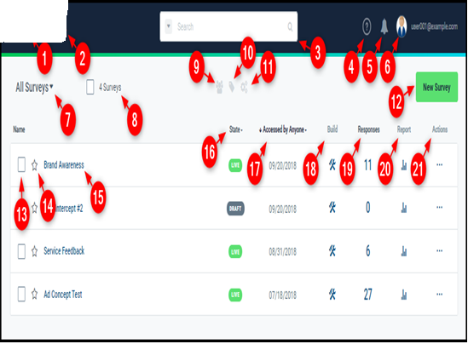

Fig 4.1 Over View of Portal

**1. PRODUCT PAGES**: Click the caret to view links to other FV products.

2. **COMPANY:** Click your company name or logo / icon to access your Company Page, where you can configure the settings and user permissions for your company.

3. **SEARCH:** Using the powerful search capabilities, you can find your projects based on project name, descriptions, tags, users and even search for specific contents, like a file name or even question text. Click the caret to see advanced search options.

4. **HELP LINKS:** Click to access your survey support resources.

5. **NOTIFICATIONS:** Click to view PM TOOL news flashes and other notifications. The bell icon will light up to let you know when there's new system updates or release news.

6. **USER PROFILE:** Click your profile picture or username to access your user profile and other options for your account.

7. **ALL SURVEYS:** Click to view or apply your saved survey views and searches. If you find an interesting view using search or sorting, you can save it to this menu to recall that view on demand. Learn more: Saved Searches

8**. SURVEY TOTAL:** Displays a count of all surveys created within your company. Check the box next to the count to add tags or apply specific actions to the selected surveys.

9. **USER ACTIONS:** When available, click to add or remove users from the selected survey(s).

10. **TAGS:** When available, click to add new tags to the selected survey(s).

11. **SURVEY ACTIONS:** When available, click to perform favoriting or archiving for multiple projects at once.

12. **NEW SURVEY:** Click to create a new survey

13. **SELECT SURVEY:** Check the box next to any survey to select it for the next action.

14. **MARK AS FAVORITE:** Click the star next to any survey to add it to your favorites list.

You can view favorited surveys using the saved views in the "All Surveys" menu.

15. **SURVEY NAME:** Click the name for any survey to navigate to its Project Overview page. The Project Overview page displays project performance stats, including key data from the Response Summary and campaign information. Additionally, it allows you access to the project's user and group controls, as well as any shared files or saved reports. Learn more: The Project Overview Page

16**. STATE:** The current state of each survey. Click to filter surveys by one or more specific states.

17**. SORT BY:** Sorts all displayed surveys by the selected criteria. Click to sort surveys by survey path, directory, or when the survey was last accessed or edited. You can also sort surveys based on respondent activity and decide whether to show newer or older events first.

18. **BUILD:** Click the "Build" icon to edit the survey within the Survey Editor.

19. **RESPONSES:** Displays the current response count for the survey. Can be real or simulated data. Click the "Responses" icon to access the Response Summary page.

20. **REPORT:** Click the "Report" icon to view the survey data in Crosstabs.

21. **ACTIONS:** Click the "..." icon to view the Survey Actions menu.

## 4.4.2 CREATING A NEW PROJECT:

When creating a new project, you can either start from scratch or by importing a questionnaire into the Survey Editor. In this lesson, we'll look at accessing the Survey Editor and starting a new project using both methods.

## SURVEY EDITOR WORKSPACE

* The Survey Editor workspace is split into three distinct sections:
* The question tree displays all of the survey's elements in a linear order.
* The stage allows users to update question text and answer options.
* The options panel allows users to manage some of the more advanced settings for questions and answer options.

## 4.4.3 BASIC QUESTION TYPES

Certain question types like single- or multi-choice are considered survey staples, and the Survey Editor includes customizable templates for these and most other common question types. In this lesson, we'll learn how to program the following basic question types from a questionnaire:

**SINGLE SELECT:**

Allows respondents to select one answer in a list of options.

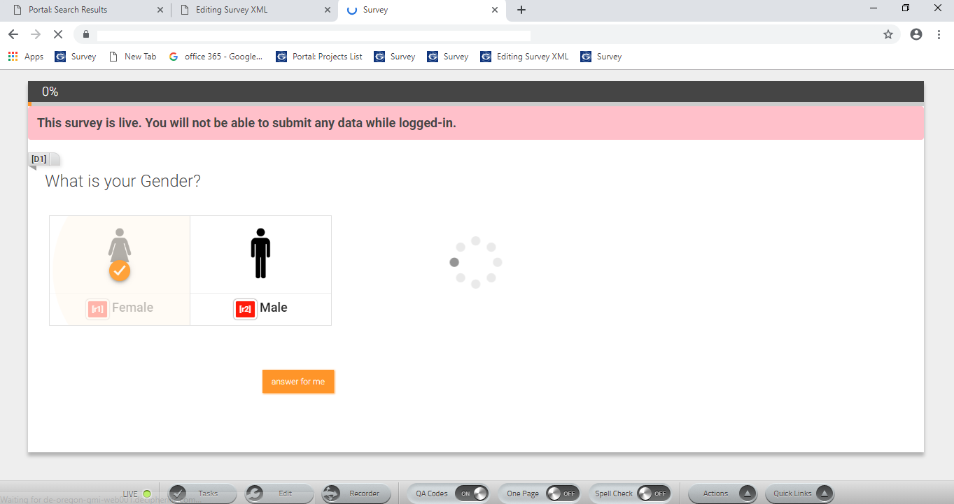

Fig 4.2 Single Select

**SINGLE SELECT GRID:**

 Allows respondents to select one answer in a 2-dimensional grid layout.

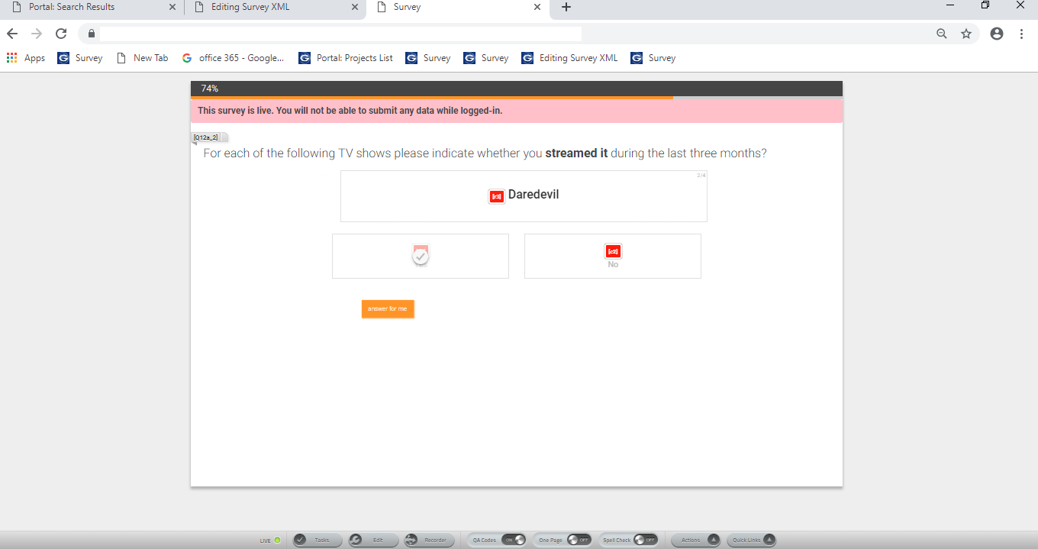

Fig 4.3 Single Select Grid

**MULTI-SELECT:**

Allows respondents to select multiple answers from a list of options.

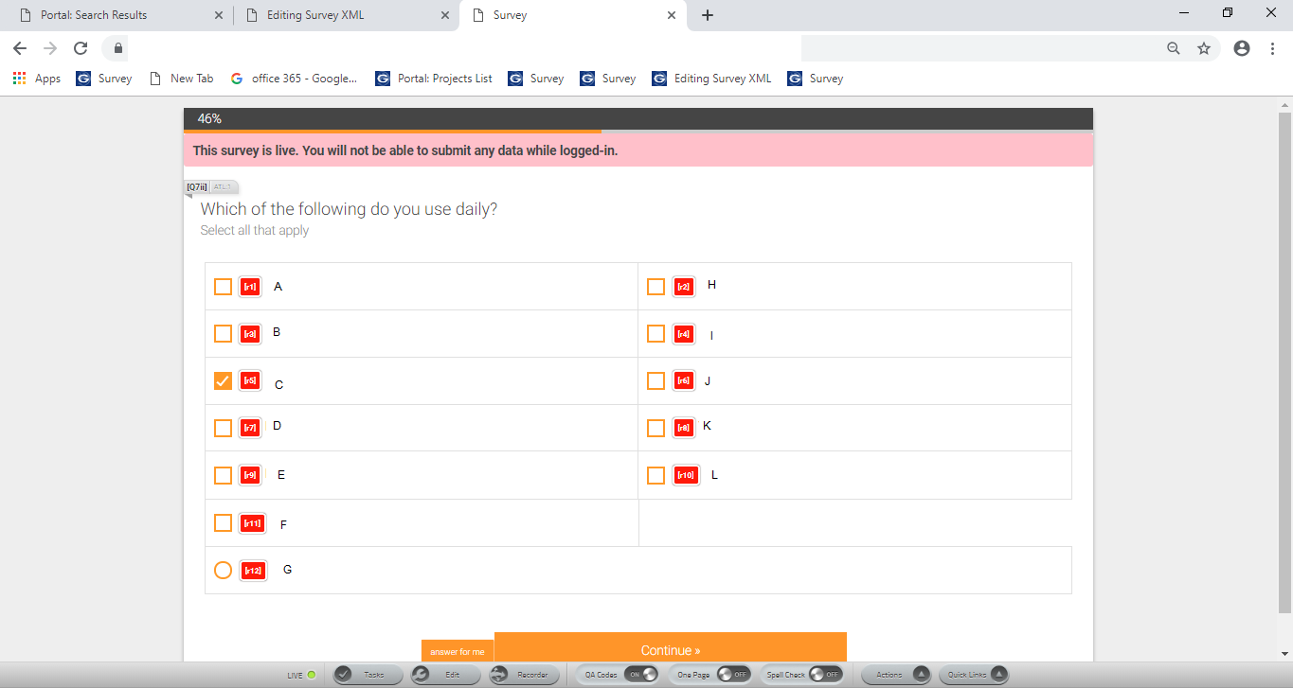

Fig 4.4 Multi Select

**MULTI-SELECT GRID:**

 Allows respondents to select multiple answers in a 2-dimensional grid layout.

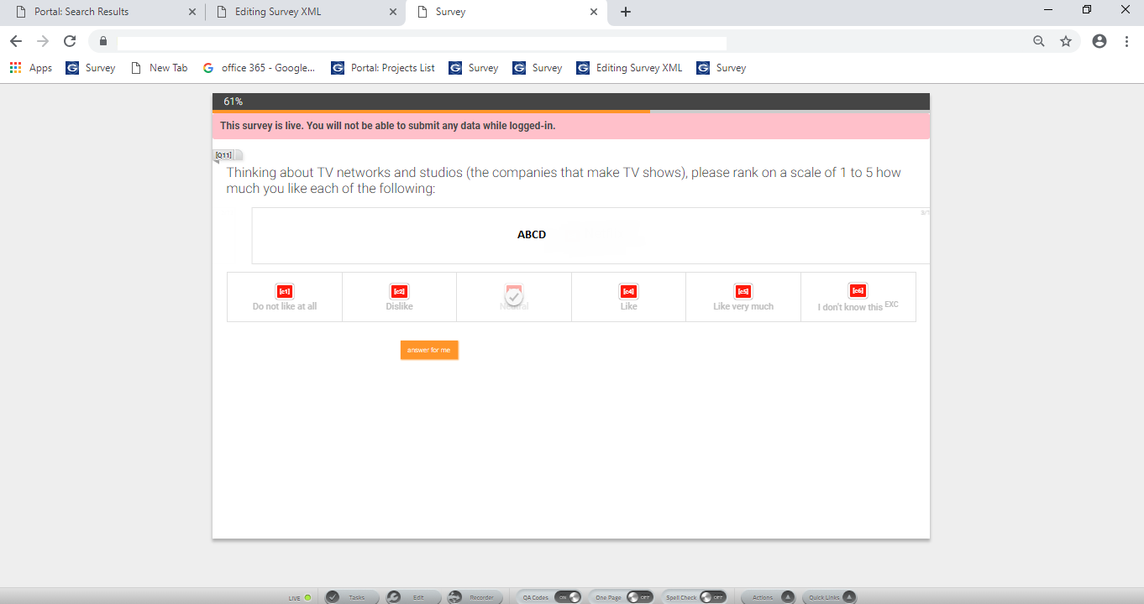

Fig 4.5 Multi Select Grid

**DROPDOWN MENU:**

Allows respondents to select one answer from a drop-down menu of options.

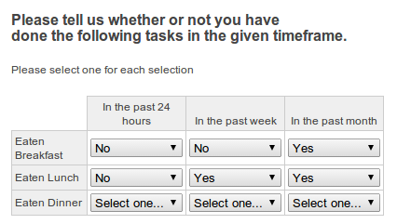

Fig 4.6 Drop down

**NUMBER:**

Allows respondents to enter a numeric response in an open-ended answer field.

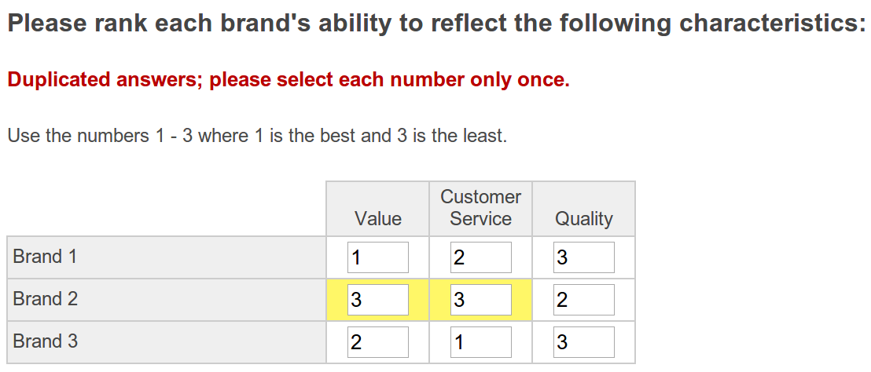

Fig 4.7 Number type

**TEXT:**

Allows respondents to enter a text response in an open-ended answer field.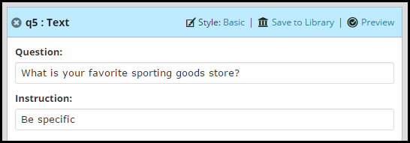

Fig 4.8 Text

**ESSAY:**

Allows respondents to enter a text response in a larger open-ended answer field than the traditional Text question type.

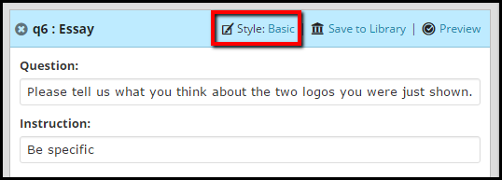

Fig 4.9 Essay type

**DESCRIPTIVE CONTENT:**

Displays text and/or multimedia elements to respondents without requiring interaction.

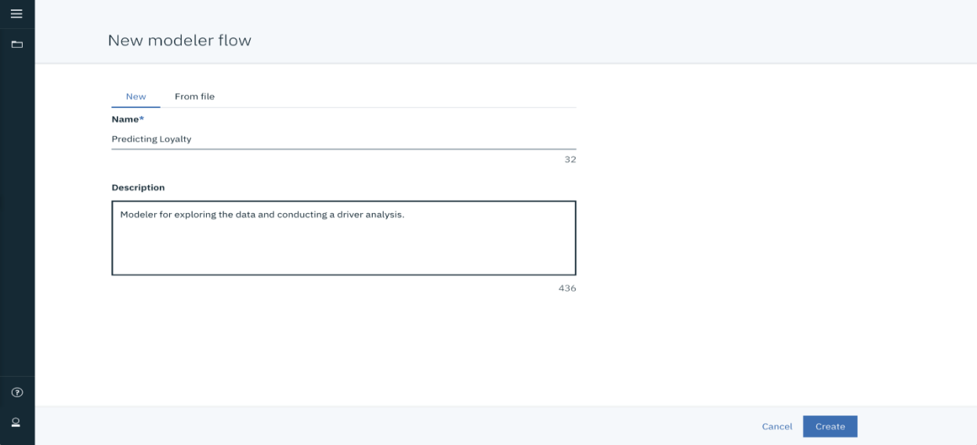

Fig 4.10 Descriptive

**DYNAMIC QUESTION TYPES:**

Along with the basic question types covered above, the Survey Editor includes templates for a variety of dynamic question types which provide enhanced usability, respondent engagement, and data quality. In this lesson, we'll learn how to program the following dynamic question types from a questionnaire-

**BUTTON SELECT:**

Allows respondents to select one answer in a list of options.

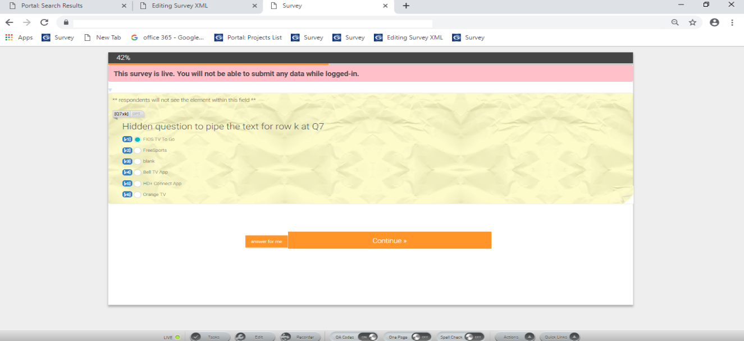

Fig 4.11 Button Select

**RATING SCALE:**

 Allows respondents to select one answer in a 2-dimensional grid layout.



Fig 4.12 Rating

**SLIDER**:

Allows respondents to select multiple answers from a list of options.

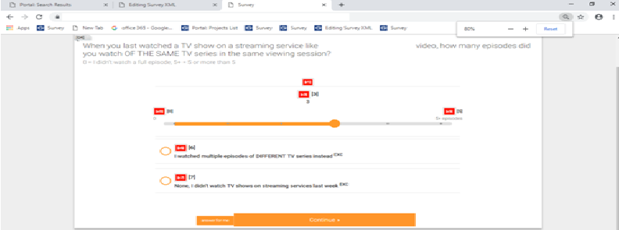

Fig 4.13 Slider

**STAR RATING:**

Allows respondents to select multiple answers in a 2-dimensional grid layout.

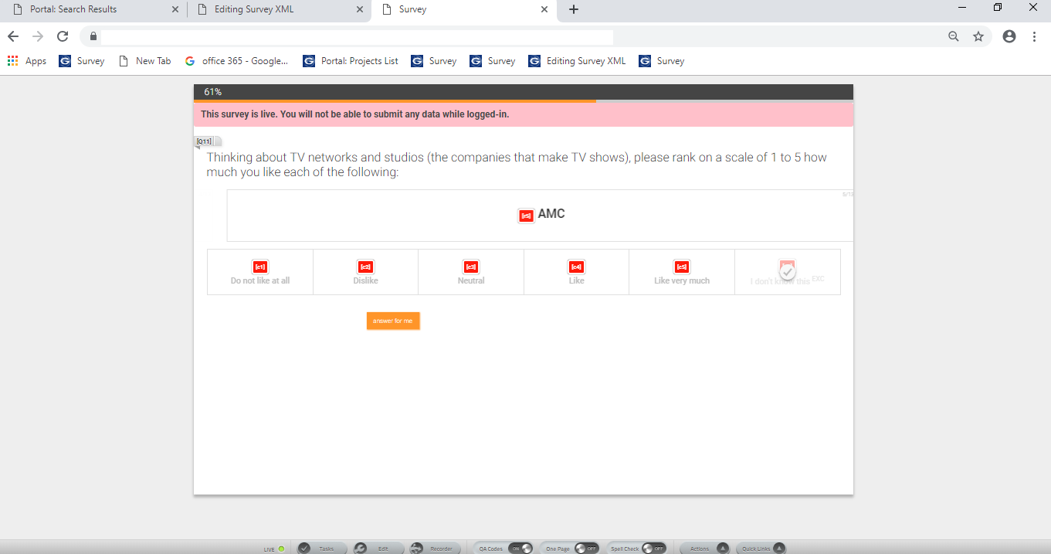

Fig 4.14 Star Rating

**RANK SORT:**

 Allows respondents to select multiple answers from a drop-down menu of options.

**CARD RATING:**

Allows respondents to rate multiple response cards displayed one at a time.

**NOTE:** Although dynamic questions use basic question types as their foundations, the data may not be directly comparable. When employing dynamic questions, be sure to develop standards and maintain consistency in how they are customized; this ensures the relative values of data can be interpreted without concern that the question format is biasing results in some way.

## ELEMENT LIBRARY

The Element Library allows users to store commonly used elements for future use in their current survey or other projects, making it easy to reuse things like demographic questions, screener questions, or even brand lists. The following items are storable in the Element Library:

Entire questions/elements

Multiple questions (can be used to create survey templates)

Answer options

## 4.4.4 ADDING & MANAGING IMAGES

The Image Manager allows users to add images to a survey and easily update any existing images. In this lesson, we'll learn how to add images to our survey through the Image Manager. We'll also learn how to resize images for viewing on different devices and how to add protections to avoid un-permitted distribution or use of our images.

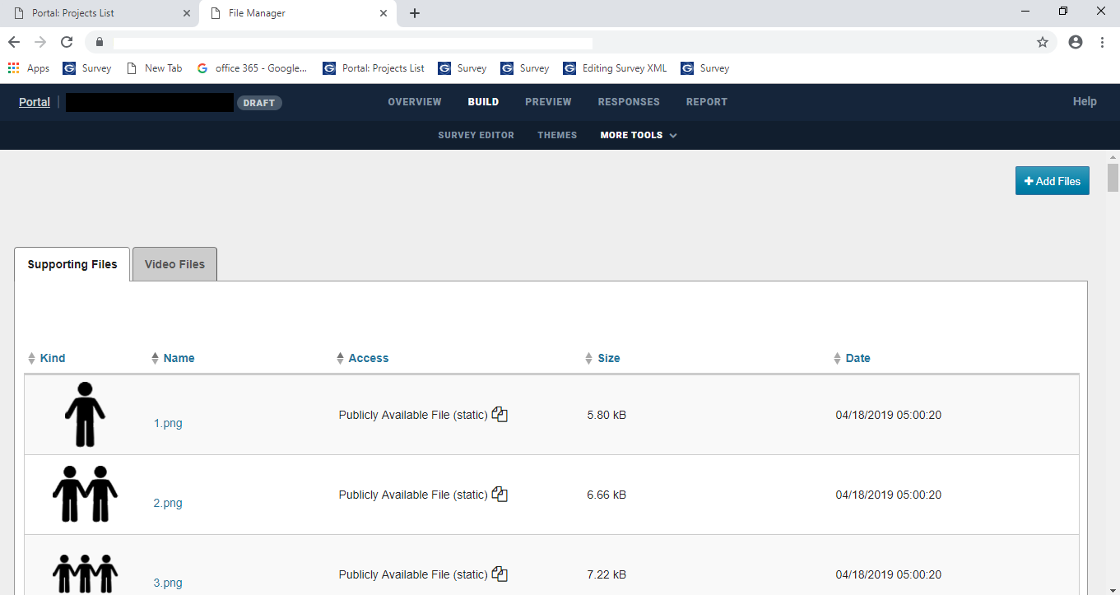

Fig 4.15 Adding & Managing

**4.4.5 STYLE EDITOR:**

It is also possible to configure the display settings for most basic and interactive elements within the Survey Editor. In this lesson, we'll learn how to adjust the configurations for both a basic and dynamic question in our test survey.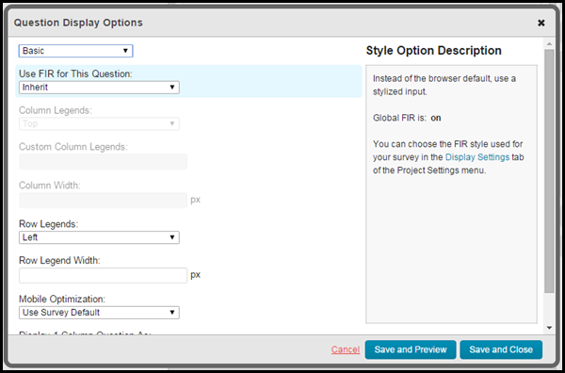

Fig 4.16 Editor

## 4.4.6 DATA VERIFIERS

A data verifier is an attribute which can be used on a text, essay or number element to restrict responses to a format. These built-in "verify" attributes are accessible in the Survey Editor and can be applied to answer options or to a question as a whole. If applied at the question level, the responses for each input will be checked against the regular expressions and must match to be accepted.

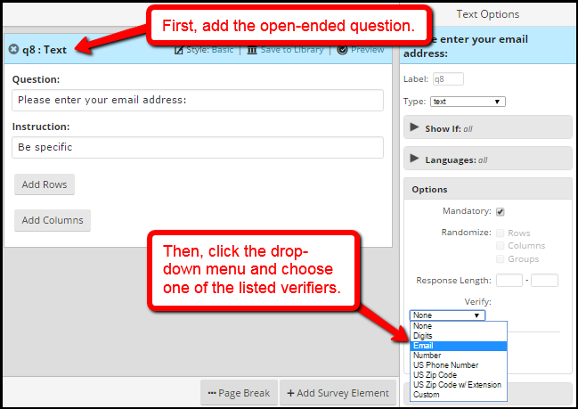

Fig 4.17 Data Verifier

## E.G: EMAIL VALIDATION:

## 

Fig 4.18 Example

## 4.4.7 ADDING LOGIC

Applying logic conditions to a survey can greatly improve the quality of the data collected. In this lesson, we will learn how to add logic conditions to survey questions and about how these additions can lead to us gathering more accurate data.

## ADDING LOGIC BASED ON QUESTION TYPE:

### **1-DIMENSIONAL QUESTIONS**

# In a 1-dimensional question, the question has rows, columns or choices.

After selecting "+condition" from the "Show If" drop down menu in options, the "Set up Logic Conditions" pop up window will appear. Select the question you want to use for the logic from the drop-down menu, select "is" or "is NOT" from the drop down menu, then select the answer choices that will define the logic. Select "Save," or "Save As" if you wish to name the condition for later use in the survey editor.

Example: Logic based on a single-select element (1-dimensional question)

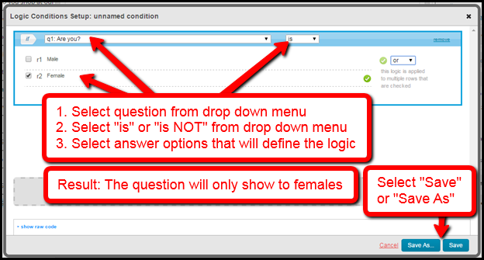

Fig 4.19 DIMENSIONAL QUESTIONS

**Example: Logic based on a multi-select element (1-dimensional question)**

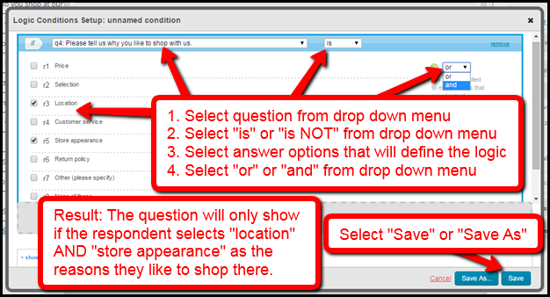

Fig 4.20 DIMENSIONAL QUESTIONS Ex1

### **2-DIMENSIONAL QUESTIONS**

# In a 2-dimensional question, the question has rows and columns, rows and choices, or columns and choices.

In this example we are going to add logic that only shows the question to respondents that prefer to shop for books and tools online.

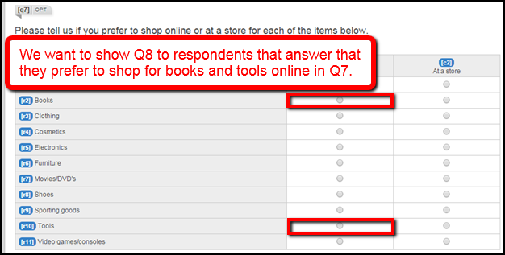

Fig 4.21 DIMENSIONAL QUESTIONS Ex2

After selecting "+condition" from the "Show If" drop down menu in options, the "Set up Logic Conditions" pop up window will appear. Select the question you want to use for the logic from the drop-down menu, select "is" or "is NOT" from the drop-down menu, then select the row or column answer choice from the drop-down menu. If the question is "grouped by" rows, the row choices will appear in the drop-down menu, and if the question is "grouped by" columns, the column choices will appear in the drop-down menu.

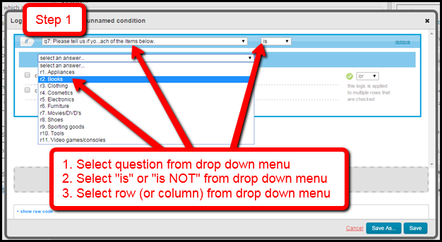

Fig 4.22 DIMENSIONAL QUESTIONS Ex3

Once the row is selected the answer choices for the columns will appear. Select the column(s) that will define the logic. In this example we want to add more logic, so we will need to select the "+add more logic" icon. Alternatively, you may select "Save," or "Save As" if you wish to name the condition for later use in the survey editor, if your logic is complete at this point.

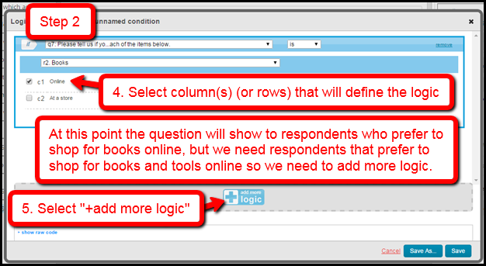

Fig 4.23 DIMENSIONAL QUESTIONS Ex 4

After we select the "+add more logic" icon a summary of the logic we've created will appear, along with a new box with the same options we had in step 1. Select the question you want to use for the logic from the drop-down menu, select "is" or "is NOT" from the drop-down menu, then select the row or column answer choice from the drop-down menu.

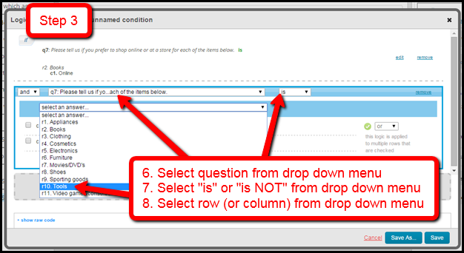

Fig 4.24 DIMENSIONAL QUESTIONS Ex 5

Once the row is selected the answer choices for the columns will appear. Select the column(s) that will define the logic. Then select "and" or "or" from the drop-down menu. We want respondents that prefer to shop for books and tools online, so we will select "and."

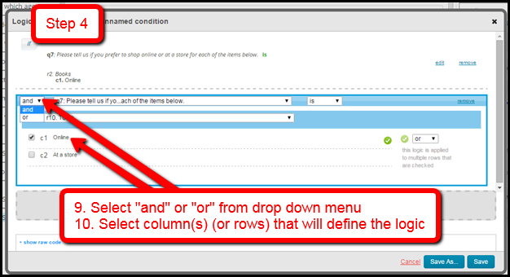

Fig4.25 DIMENSIONAL QUESTIONS Ex 6

Once your logic is complete, review it one last time to confirm it is correct, then select "Save," or "Save As" if you wish to name the condition for later use in the survey editor.

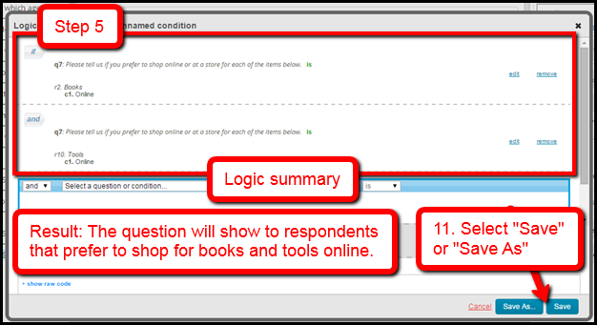

Fig 4.26 DIMENSIONAL QUESTIONS Ex 7

## 4.4.8 ELEMENTS:

## BLOCK ELEMENT:

In this lesson, we will learn how to add the block element to a survey. We will also learn how the block element can be used to group questions together, display a section of survey elements in random order, or restrict several questions by the same logic.

Note: A block will not show to respondents taking the survey.

## LOOP ELEMENT:

The loop element allows users to ask the same question(s) of a respondent multiple times, typically for each applicable value of a variable. In this lesson, we'll learn about adding the loop element to a survey to save ourselves time on programming questions and implementing complex piping.

## SKIP ELEMENT:

The skip element can be used to route respondents from one survey question to a targeted question later on in the survey. In this lesson, we'll learn how to add a skip element to our survey.

## AUTOFILL ELEMENT:

The autofill element is a hidden element that can be used to create hidden segments for auto-punching or advanced piping. In this lesson, we'll learn about the autofill element and attempt to program three different types of autofill into our survey.

## QUOTA ELEMENT:

In this lesson, we'll take an in-depth look at the quota element. The quota element manages flow through a survey by restricting the number of respondents allowed through it. We'll also take a look at the three different quota types available in the Survey Editor:

**QUESTION ANSWERS ("QUICK QUOTAS"):**

Add quota cells based on responses from selected 1-dimensional survey questions.

**LOGIC CONDITIONS:**

Add quota cells based on new or existing survey logic conditions.

**RANDOMLY ASSIGN QUOTAS (+QUOTAS):**

Add quota cells that respondents will be randomly assigned to.

## 4.4.9 SAMPLE SOURCES

A sample source is simply the method by which a respondent gets to and from a survey. Common sample sources include purchased panel sample, private panel sample, direct email sends, and intercepts from websites. The sample source also defines any variables that should be gathered, stored, and/or passed back through the survey exit pages or URL.

In this lesson, we'll learn how to add sample sources to our survey, and how to set up a pre-programmed sample source which includes the URL variables and exit links configured for individual panel vendors. We'll also explore creating custom sample sources in which the variables and exit pages are added manually.

## 4.4.10 THEME EDITOR OVERVIEW:

In this lesson, we'll learn how to customize the appearance of our survey by adding a logo and applying a theme. We'll also learn how to use these tools to make our project more engaging for respondents.

## 4.4.11 UPLOAD SYSTEM FILES:

Moving on, it's time to familiarize ourselves with the PM TOOLsystem files. In this lesson, we'll be introduced to the PM TOOLfile manager, the different directories within a project, and some of the supporting files in a PM TOOLsurvey.

**4.5 DATA VALIDATAION AND PREPRATION:**

**4.5.1 PM TOOL – WHAT IS IT?**

PM Tool was first launched in 1968. Since it was acquired by NSMX in 2011, it's officially known as NSMX PM TOOL.

**4.5.2 PM TOOL** **- QUICK OVERVIEW MAIN FEATURES**

PM Tool is software for editing and analyzing all sorts of data. These data may come from basically any source: scientific research, a customer database, Google Analytics or even the server log files of a website. PM TOOL can open all file formats that are commonly used for structured data such as

* Spreadsheets from MS Excel or [Open Office](https://www.openoffice.org/);
* Plain text files (.txt or .csv);
* Relational (SQL) databases;

**4.5.3 PM TOOL DATA VIEW**

After opening data, PM Tool displays them in a spreadsheet-like fashion as shown in the screenshot below from freelancers. Sav.

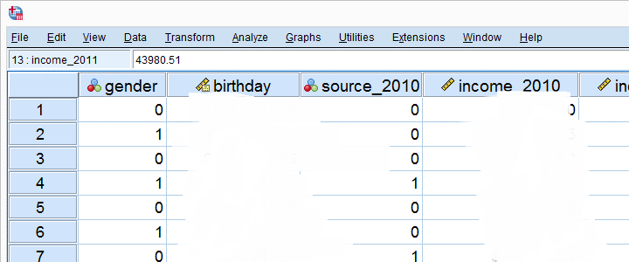

Fig 4.27 DIMENSIONAL QUESTIONS Ex 8

This sheet -called [data view](https://www.spss-tutorials.com/spss-data-editor-window/#spss-data-view)- always displays our data values. For instance, our first record seems to contain a male respondent from 1979 and so on. A more detailed explanation on the exact meaning of our variables and data values is found in a second sheet shown below.

**4.5.4 PM TOOL VARIABLE VIEW**

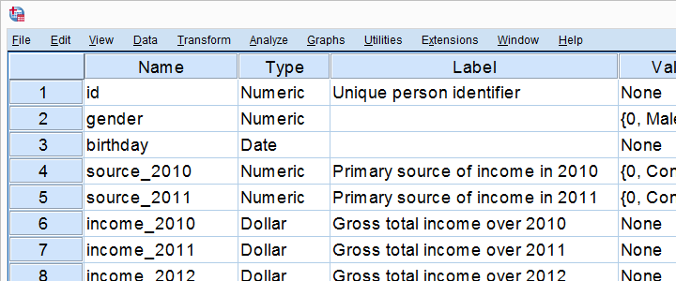

Fig 4.28 Variable View

An PM Tool  data file always has a second sheet called [variable view](https://www.spss-tutorials.com/spss-data-editor-window/#spss-variable-view). It shows the metadata associated with the data. Metadata is information about the meaning of variables and data values. This is generally known as the “codebook” but in PM Tool it’s called the [dictionary](https://www.spss-tutorials.com/spss-dictionary/).

For non-PM Tool users, the look and feel of PM Tool  Data Editor window probably come closest to an Excel workbook containing two different but strongly related sheets.

**4.5.5 DATA ANALYSIS**

Right, so PM Tool can open all sorts of data and display them -and their metadata- in two sheets in its Data Editor window. So how to analyses your data in PM Tool? For instance, if our data contain a variable holding respondents’ incomes over 2010, we can compute the average income by navigating to Descriptive Statistics as shown below.

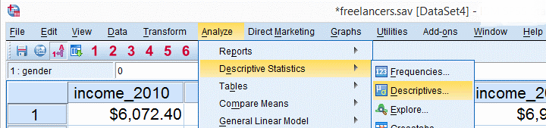

Fig 4.29 Data Analysis 1

Doing so opens a dialog box in which we select one or many variables and one or several statistics we'd like to inspect.

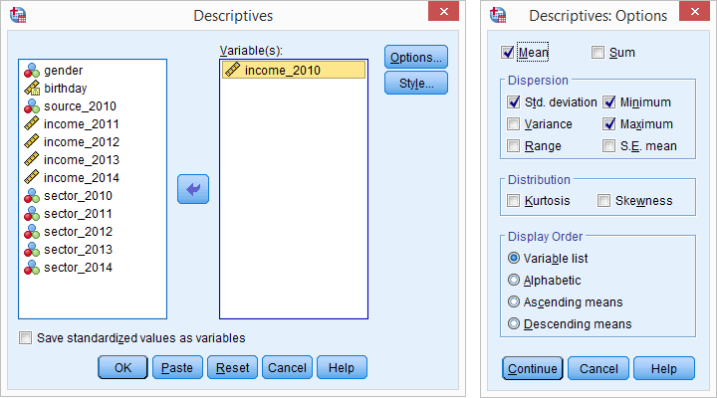

Fig 4.30 Data Analysis 2

**4.5.6 PM TOOL Output Window**

After clicking Ok, a new window opens: PM Tool [output viewer window](https://www.spss-tutorials.com/spss-output/). It holds a nice table with all statistics on all variables we chose. The screenshot below shows what it looks like.

.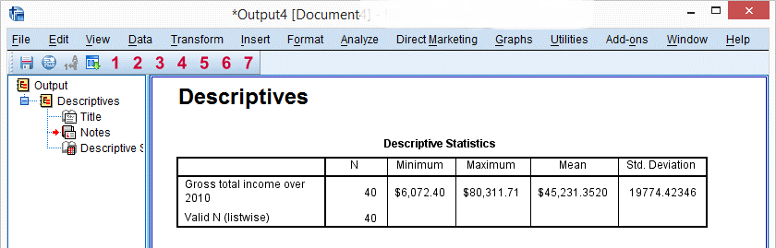

Fig 4.31 Output Window

As we see, the Output Viewer window has a different layout and structure than the Data Editor window we saw earlier. Creating output in PM Tool  does not change our data in any way; unlike Excel, PM Tool  uses different windows for data and research outcomes.   
  
For non-PM Tool  users, the look and feel of PM Tool  Output Viewer window probably comes closest to a PowerPoint slide holding items such as blocks of text, tables and charts.

**4.5.7 PM TOOL REPORTING**

PM Tool Output items, typically tables and charts, are easily copy-pasted into other programs. For instance, many PM TOOL users use a word processor such as MS Word, OpenOffice or Googled for reporting. Tables are usually copied in rich text format, which means they'll retain their styling such as fonts and borders. The screenshot below illustrates the result.

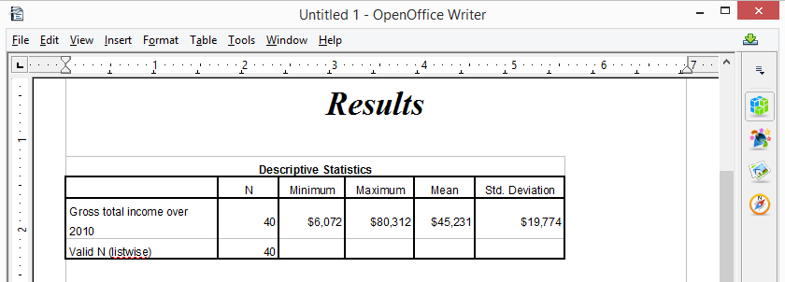

Fig 4.32 Reporting

Chapter 5

**Literature Review**

Recruiting professional programmers in sufficient numbers for research studies can be challenging because they often cannot spare the time, or due to their geographical distribution and potentially the cost involved. Online platforms such as Clickworker or Qualtrics do provide options to recruit participants with programming skill; however, misunderstandings and fraud can be an issue. This can result in participants without programming skill taking part in studies and surveys. If these participants are not detected, they can cause detrimental noise in the survey data. In this paper, we develop screener questions that are easy and quick to answer for people with programming skill but difficult to answer correctly for those without. In order to evaluate our questionnaire for efficacy and efficiency, we recruited several batches of participants with and without programming skill and tested the questions. In our batch 42% of Clickworkers stating that they have programming skill did not meet our criteria and we would recommend filtering these from studies. We also evaluated the questions in an adversarial setting. We conclude with a set of recommended questions which researchers can use to recruit participants with programming skill from online platforms.[1]

There are few resources geared to technical writers working on documentation for software developers. This paper presents the results of online surveys and telephone interviews that cover the experience, technical knowledge, and practices of technical writers in this area, with a large percentage of respondents who are Microsoft employees. Respondents value strong writing skills and the ability to learn quickly and continuously, with the amount and type of knowledge needed being specific to the subject area and audience for their work.[2]

A comparison was made on perceptions on 26 factors relating to motivation, satisfaction, and goal setting/feedback for programmer/analysts and programmers in the U.S. Israel, and Singapore. Surveys of over 550 Israelis and 1100 Singaporeans were compared to a US database on more than 8000 computer personnel. The Job Diagnostic Survey for Data processing (JDS/DP) instrument was used to collect all data. The survey results indicated a mismatch in individual growth need and the job's motivating potential for programmers in Israel and Singapore. A mismatch also exists for Singaporean programmer/analysts. A procedure for improvement is discussed.[3]

Learning by Imitation (LBI) is the most natural way of learning natural languages. The designers of online courses focus on approaches like learning by doing, adaptive learning, and so on for designing online education systems like Massive Open Online Courses (MOOC) and Intelligent Tutoring System (ITS). They don't consider LBI as an essential parameter while designing courses and MOOC/ITS for naive programmers. The purpose of this research is to arrive at a framework that helps in designing pedagogically effective MOOC/ITS for naive programmers which reflects LBI approach. We conducted an online survey where 130 students participated. Online lectures were designed using our reference framework. A desktop App was developed for naive programmers allowing them to code at different levels of abstractions. The Lectures plus App provides a learning environment reflecting LBI. We conducted pre and post-tests and found a remarkable increase in programming performance of these participants.[4]

Within computer science education, we have spent considerable effort on the introduction to the discipline (particularly to programming) and the teaching of novice programmers. However, we do not often think about the teaching and learning for the intermediate students. Having data about student's perceptions coming into a second year data structures course, it became of interest to systematically analyze the data to see what if any interesting patterns or results we could see in this information. Using the data from a first day of class general survey, we were able to gather information about student's perceived level of difficulty with some of the major topics that they have studied up until this point in the curriculum. The first half of the survey consisted of ten Likert-type items representing ten different topics in the previous courses. We are able to present quantitative analysis of the students perceived level of difficulty with these topics. The second half of the survey asked several open-ended questions about their learning. In this paper, we also provide analysis of the first of these questions which asked them to identify a topic that they studied previously that they still do not understand well. While not yet giving us the ability to generalize, this data shows some interesting information about students' perceived difficulty at a point in the curriculum that is not often studied, the intermediate years, and the results make an interesting case for further exploration of this problem with a larger group of students at more and diverse institutions.[5]

This paper aims to evaluate usability factors of online satisfaction survey system for public healthcare service. The evaluation was performed to analyze issues of usability factors, which is relevant to user interface design by applying Analysis Hierarchy Process (AHP) to prioritize their level of challenges. The study focuses on 10 Jakob Nielsen's heuristics principles as main usability factors. Based on main factors, 43 sub-factors are determined. Relevant data was collected through questionnaires by surveying 24 persons, including programmers, system analyst, students, lecturers, and general users. Next, researchers calculated values of data by using Expert Choice. The result shows the first 5 levels of usability factors that are challenges in a form of percentage rate respectively. The factors of recognition rather than recall (81%); help users recognize, diagnose, and recover from errors (78%); match between system and real world (77%); user control and freedom (76%) and consistency and standards (74%). The challenge rate of all usability factors reveal 72% while non-challenge rate is only 28%. From the result of this study we can conclude that existing online applications of satisfaction survey system for public healthcare service need to be improved. The improvement can be taken by prioritizing the usability factors based on level of challenges that found in this study.[6]

The object-oriented paradigm is becoming increasingly popular as a result of expert opinion and anecdotal evidence and not on the basis of sound empirical data. The questionnaire survey was undertaken as part of a programme of research to validate unsupported claims about the paradigm. The questionnaire follows structured interviews of experienced object-oriented developers with the intention of confirming the findings on a wider practitioner group. It was posted to relevant electronic newsgroups and to members of an object-oriented (postal) mailing list. The survey received 167 responses to the electronic questionnaire and 119 responses (30% response rate) to the postal version. Results show that respondents are of the view that:

1. the object-oriented paradigm has advantages over other paradigms in terms of ease of analysis and design, programmer productivity, software reuse, and ease of maintenance;
2. inheritance can introduce difficulties when trying to understand object-oriented software;
3. missing design documentation and poor or inappropriate design are prevalent problems;
4. maintenance causes degradation of object-oriented software, but less frequently than conventional software;
5. C++ has many deficiencies in comparison to other purer object-oriented languages.[7]

This paper lights on Python amongst other different programming paradigms used in the IT World, which enhances development speed. Although, Python was conceptualized in the late 1980s and after its implementation in 1989, it has emerged as a new multi-paradigm language platform with advent of Big Data. Python includes various data structures, standard libraries with the implementation of sentiment analysis and data science code. The real aim is to provide awareness to all the programmers about various facts of python language. It tells how Python works with various commercial and social communities and provides complete and desirable results. There are many areas and applications where Python makes its own stand as compared to other programming languages.[8]

In recent years, the extensive application of the Python language has made its analysis work more and more valuable. Many static analysis algorithms need to rely on the construction of call graphs. In this paper, we did a comparative empirical analysis of several widely used Python static call graph tools both quantitatively and qualitatively. Experiments show that the existing Python static call graph tools have a large difference in the construction effectiveness, and there is still room for improvement.[9]

Data Profiling and data quality management become a more significant part of data engineering, which an essential part of ensuring that the system delivers quality information to users. In the last decade, data quality was considered to need more managing. Especially in the big data era that the data comes from many sources, many data types, and an enormous amount. Thus it makes the managing of data quality is more difficult and complicated. The traditional system was unable to respond as needed. The data quality managing software for big data was developed but often found in a high-priced, difficult to customize as needed, and mostly provide as GUI, which is challenging to integrate with other systems. From this problem, we have developed an opensource package for data quality managing. By using Python programming language, Which is a programming language that is widely used in the scientific and engineering field today. Because it is a programming language that is easy to read syntax, small, and has many additional packages to integrate. The software developed here is called “Sakdas” this package has been divided into three parts. The first part deals with data profiling provide a set of data analyses to generate a data profile, and this profile will help to define the data quality rules. The second part deals with data quality auditing that users can set their own data quality rules for data quality measurement. The final part deals with data visualizing that provides data profiling and data auditing report to improve the data quality. The results of the profiling and auditing services, the user can specify both the form of a report for self-review. Or in the form of JSON for use in post-process automation.[10]

The accuracy of medical diagnosis depends on the accuracy of image recognition, so the details of the preprocessing of medical images are more stringent, especially the edges of images that contain a lot of information need to be enhanced. Therefore, this article chooses to combine various enhancement methods in the spatial domain and apply python software to medical image enhancement. The experimental results show that the algorithm not only effectively retains the texture and details in the medical image, but also enhances the contour and edge of the medical image, so that some details that cannot be observed by the naked eye appear. At the same time, the use of python makes the whole algorithm more realized. Fast and more conducive to medical staff to observe the focus of the medical image.[11]

Computing historians might someday refer to 2005 as the year of XML. Many have anticipated the promise of XML for almost a decade, but major industry players finally accepted in 2005 that the nuts and bolts of XML processing in the heart of their networks will demand new ways of thinking. This analysis specializes in Web services and service-oriented architecture (SOA) issues.[12]

XML-SNMP based network management model is essential parts of the network management infrastructure. It is generally recognized that there are two problems remained unsolved for this kind of model. These two problems are load balance of the XML manager and the potential bottleneck of the XML/SNMP gateway. This paper presents a novel XML-template based approach to tackle these two problems. We developed three XML templates including host, graph, and data query templates. This paper gives detail discussion of the three templates in regard of the structure, content and relationship as well as the mapping mechanism in the relational databases. The experimental results performed on a real deployed XML-SNMP system demonstrate the effectiveness of the proposed approach. When compared with traditional XML-SNMP system, our approach effectively reduces the types and quantities of management data and overhead of translation between XML and SNMP. The proposed approach solves the load balance and bottleneck issues resulting in significantly overall performance improvement of the XML-SNMP model.[13]

Since there has been significant amount of XML documents generated in various application domains, efficient XML management has become an important problem. Distributed XML storage and parallel query based on Map Reduce can be an effective solution to this problem. As XML data placement strategy is a key factor of parallel system performance, in this paper we present an XML placement strategy, which is Query Workload Estimation based XML Placement strategy (QWEXP) for efficient distributed XML storage and parallel query. To achieve query workload balance, it partitions XML based on query workload estimation which is calculated by XML structure without knowing of user queries, considering that in common application scenarios user queries are unknown in advance. The partitioned XML segments are around an XML storage unit W0, to support scalability of parallel XML database. Finally segments are distributed to each processing node evenly to ensure workload balance on parallel query execution. Experimental results have shown that QWEXP promotes the speedup and scale up properties of parallel XML system greatly.[14]

The aim of this system is to use open source APIs to invoke and process the results of the Web services and to apply confidentiality and integration to the result of the Web services. In this system Web Services are requested using URL (Uniform Resource Locator) query to the WWW instead of SOAP message. When invoking the web services using JAX-RPC (Java Api for Xml-Based Remote Procedure Call) with SOAP request, the result returned may not be received properly due to de-serialization problem of complex XML data sets. Therefore it is required to invoke such services by submitting the query as URL query and received the results as XML data set. This XML data set may be hampered by man-in-middle attack during transfer. Hence this system uses open source APIs for providing XML signature and XML encryption. At the receiver after decryption and integrity check, the required node from XML data set is extracted and presented to the user. This article is focused on usage of open source APIs (Application program interface) for invoking web services as Restful Web services, applying XML signature and XML encryption, parsing the XML result after reverse process at receiver side and extracting the required nodes according to the user given condition. The problem of de-serialization in receiving huge XML result is resolved in the proposed system.[15]

Chapter 6

**APPENDICES**

* Scope of marketing research means the possible applications of marketing research in corporate environment.
* Bulk of research is done to measure consumer needs and wants. Besides, marketing research is carried out to assess the impact of past marketing actions.
* Some research is done to understand the competitive, technological, social, economic, cultural, political or legal environments of the market.

**REFERENCES**

# [1] [Anastasia Danilova](https://ieeexplore.ieee.org/author/37086049276), [Alena Naiakshina](https://ieeexplore.ieee.org/author/37086059147), [Stefan Horstmann](https://ieeexplore.ieee.org/author/37088898780), [Matthew Smith](https://ieeexplore.ieee.org/author/37085506258). “Do you Really Code? Designing and Evaluating Screening Questions for Online Surveys with Programmers” ***Published in:*** [*2021 IEEE/ACM 43rd International Conference on Software Engineering (ICSE)*](https://ieeexplore.ieee.org/xpl/conhome/9401807/proceeding)

# [2] [C. Bottomley](https://ieeexplore.ieee.org/author/37972758600). “What part writer? What part programmer? A survey of practices and knowledge used in programmer writing” ***Published in:*** [*IPCC 2005. Proceedings. International Professional Communication Conference, 2005.*](https://ieeexplore.ieee.org/xpl/conhome/10002/proceeding)

# [3] J.D. Couger. “Comparison of motivating environments for programmer/analysts and programmers in the US, Israel and Singapore” ***Published in:***[*[1989] Proceedings of the Twenty-Second Annual Hawaii International Conference on System Sciences. Volume IV: Emerging Technologies and Applications Track*](https://ieeexplore.ieee.org/xpl/conhome/235/proceeding)

# [4] [Siddharth Srivastava](https://ieeexplore.ieee.org/author/37087140449), [Shalini Lamba](https://ieeexplore.ieee.org/author/37087140366), [T.V. Prabhakar](https://ieeexplore.ieee.org/author/37541465500). “Improving Learning by Imitation in Online Courses using Memorization, Learning by Doing and Lecture Architecture for Naive Programmers” ***Published in:***[*2020 IEEE 20th International Conference on Advanced Learning Technologies (ICALT)*](https://ieeexplore.ieee.org/xpl/conhome/9146898/proceeding)

# [5] [Adrienne Decker](https://ieeexplore.ieee.org/author/38490197300), [David Simkins](https://ieeexplore.ieee.org/author/38489686500). “Uncovering difficulties in learning for the intermediate programmer” ***Published in:***[*2016 IEEE Frontiers in Education Conference (FIE)*](https://ieeexplore.ieee.org/xpl/conhome/7749394/proceeding)

# [6] [Suweena Yusoh](https://ieeexplore.ieee.org/author/37086306239), [Sureena Matayong](https://ieeexplore.ieee.org/author/37888099900). “Heuristic evaluation of online satisfaction survey system for public healthcare service: Applying analytical hierarchical process” ***Published in:***[*2017 2nd International conferences on Information Technology, Information Systems and Electrical Engineering (ICITISEE)*](https://ieeexplore.ieee.org/xpl/conhome/8276203/proceeding)

[7] [J. Daly](https://ieeexplore.ieee.org/author/37353233700), [J. Miller](https://ieeexplore.ieee.org/author/37275462000), [A. Brooks](https://ieeexplore.ieee.org/author/37357479200), [M. Roper](https://ieeexplore.ieee.org/author/37284114400), [M. Wood](https://ieeexplore.ieee.org/author/37284115200). “A survey of experiences amongst object-oriented practitioners” ***Published in:***[*Proceedings 1995 Asia Pacific Software Engineering Conference*](https://ieeexplore.ieee.org/xpl/conhome/3579/proceeding)

# [8] [Arun Kumar](https://ieeexplore.ieee.org/author/37085512502), [Supriya.P. Panda](https://ieeexplore.ieee.org/author/37087041871). “A Survey: How Python Pitches in IT-World” ***Published in:***[*2019 International Conference on Machine Learning, Big Data, Cloud and Parallel Computing (COMITCon)*](https://ieeexplore.ieee.org/xpl/conhome/8851231/proceeding)

# [9] [Li Yu](https://ieeexplore.ieee.org/author/37087232730). “Empirical Study of Python Call Graph” ***Published in:***[*2019 34th IEEE/ACM International Conference on Automated Software Engineering (ASE)*](https://ieeexplore.ieee.org/xpl/conhome/8949433/proceeding)

# [10] [Sakda Loetpipatwanich](https://ieeexplore.ieee.org/author/37088548360), [Preecha Vichitthamaros](https://ieeexplore.ieee.org/author/37088548823). “Sakdas: A Python Package for Data Profiling and Data Quality Auditing” ***Published in:***[*2020 1st International Conference on Big Data Analytics and Practices (IBDAP)*](https://ieeexplore.ieee.org/xpl/conhome/9245604/proceeding)

# [11] [Hui Zhou](https://ieeexplore.ieee.org/author/37088802245), [Shuai Wu](https://ieeexplore.ieee.org/author/37088801411). “Design of medical image enhancement algorithm based on Python” ***Published in:***[*2021 IEEE International Conference on Power Electronics, Computer Applications (ICPECA)*](https://ieeexplore.ieee.org/xpl/conhome/9362508/proceeding)

# [12] [G. Goth](https://ieeexplore.ieee.org/author/37283389700). “News: XML - The center of attention up and down the stack”

# ***Published in:***[*IEEE Distributed Systems Online*](https://ieeexplore.ieee.org/xpl/RecentIssue.jsp?punumber=8968)*( Volume: 7,*[*Issue: 1*](https://ieeexplore.ieee.org/xpl/tocresult.jsp?isnumber=33769)*, Jan. 2006)*

# [13] [Ling Gao](https://ieeexplore.ieee.org/author/37274359300), [Bin Xing](https://ieeexplore.ieee.org/author/37603903000); [Jing Zhang](https://ieeexplore.ieee.org/author/37540283400), [Huan Li](https://ieeexplore.ieee.org/author/37600693200). “Developing efficient XML-SNMP model: An XML-template based approach” ***Published in:***[*2010 International Conference on Computer Application and System Modeling (ICCASM 2010)*](https://ieeexplore.ieee.org/xpl/conhome/5602791/proceeding)

# [14] [Jing Zhang](https://ieeexplore.ieee.org/author/37859985900), [Bo Lang](https://ieeexplore.ieee.org/author/37266186100), [Yawei Duan](https://ieeexplore.ieee.org/author/38241828700). “An XML Data Placement Strategy for Distributed XML Storage and Parallel Query” ***Published in:***[*2011 12th International Conference on Parallel and Distributed Computing, Applications and Technologies*](https://ieeexplore.ieee.org/xpl/conhome/6118340/proceeding)

[15] [Sumathi Pawar](https://ieeexplore.ieee.org/author/37086278788), [Niranjan N Chiplunkar](https://ieeexplore.ieee.org/author/37372168000). “Open source apis for processing the XML result of web services” ***Published in:***[*2017 International Conference on Advances in Computing, Communications and Informatics (ICACCI)*](https://ieeexplore.ieee.org/xpl/conhome/8119306/proceeding)